# Setup Challenge 1: Dream Theater Fan Files

Roie Danino 316440296

* In this specific challenge the flag is not in the “flag{band:song}” format.

1. Use <http://stewd.io/histoface/> to create images with histograms that look like actual words.

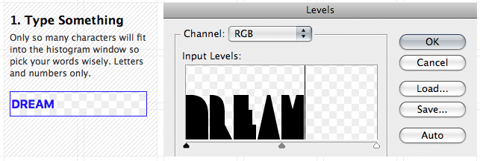

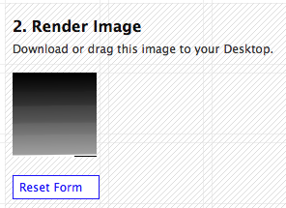

Output:

1. Make 3 of those: 1) DREAM 2) THEATER 3) OVERTURE

And those words will be the flag: {Dream Theater: Overture 1928}

1. 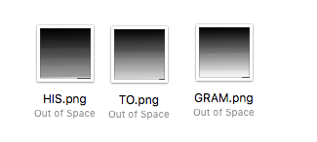Rename the files to 1) HIS 2) TO 3) GRAM to imply what we need to use to read the data from those images
2. Zip those files and hide them in the album artwork image

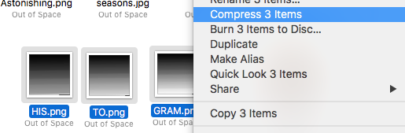

for hiding zip inside a photo: *cat orginalPic.jpg some.zip > newPic.jpg*

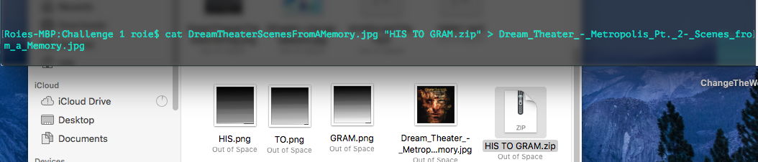

1. Now we have a picture (Dream Theater – Scenes From a Memory Artwork) that contains a zip that contains 3 photos, for making some, now download all their other albums artworks from here:

<https://en.wikipedia.org/wiki/Category:Dream_Theater_album_covers>

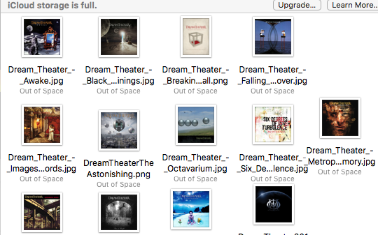

1. Zip all of those images into a single zip file “DreamTheater.zip”
2. Download “Dream Theater – Regression.mp3” from:

<http://mp3red.cc/1437800/dream-theater-regression-scene-one.html>

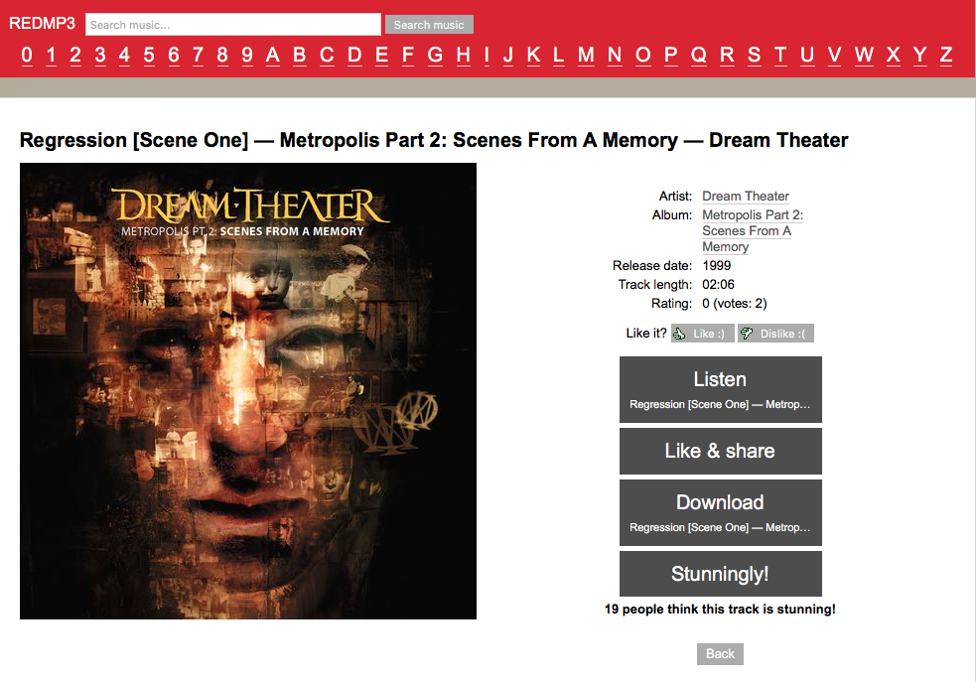

1. Now we need to hide *DreamTheater.zip* inside this song and rename this song title

